Zabbix 3.2 Installation and Configuration
Recently I began to conduct a new monitor system based on zabbix, currently we are using zenoss core 5 as our main monitor platform. but we met some shortage, one is it absence of auto-discovery capacity which need human intervention to manually add/remove hosts, the other one is its high resource consumption with high latency. Zbbix is designed with powerful auto-discovery feature and customization ability.
Through entire configuration, I appreciate the mechanism that will auto-discover the hosts and then add then to different group and link appropriate templates according to the rules. I made some notes on some key points which we need to take account into.
1. configure appropriate templates
1. configure the auto-discovery and registration
- configure email alerts

I. Installation of the software.
Configure the yum repos on centos 7.
#rpm -ivh http://repo.zabbix.com/zabbix/3.2/rhel/7/x86_64/zabbix-release-3.2-1.el7.noarch.rpm

Install zabbix
# yum install zabbix-server-pgsql zabbix-web-pgsql -y

Configure postgresql

Posgtresql will be installed as a dependency of preceding zabiix packages, now we should initialize it.
# initdb -D /var/lib/pgsql/data or pg_ctl initdb -D /var/lib/pgsql/data
**Thus posgresql data will be stored under /var/lib/pgsql/data.
- Change the authentication method in /var/lib/pgsql/data/pg_hba.conf
Each line is a record which is comprised of connection type,requested database,user name, client address(IP/subnet), auth-method, auth options to perform authentication.
First change the local to trust method and restart postgreql database.
Change the password of the postgres use inside the database
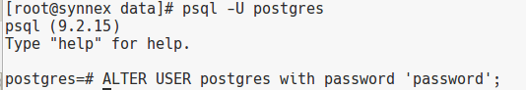
Then change it to md5 method, and restart database.
Now local user postgres can connect the database with passwd.
- Create user zabbix
we create a user(role) zabbix with login and createdb privilege which will be used in the following configuration.
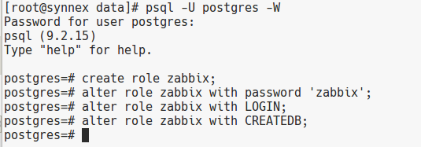
Create database zabbix with role zabbix;
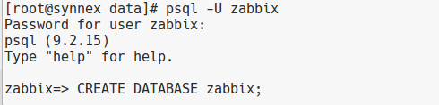

Configure /etc/zabbix/zabbix-server.conf
DBHost=localhost
DBName=zabbix
DBUser=zabbix
DBPassword=zabbix

Complete the installation via the http://ip/zabbix/

II. configure templates
First we must have a overall concepts what metrics we need to care about, from our point of view, we need to consider these items.

- if the host is up or down, we may make use official icmp template to check the host running status
- we need to monitor the cpu usage, CPU IDLE may be a good choice
- we may take memory usage into account, so toal memory/used memory/usage percentage are what we want
- we are also track the disk usage, total/used/usage percentage should be considered.

Second, we have to choose the proper protocol to collect these data from remote servers, here we use SNMP.

set up the macros SNMP_COMMUNITY;
Admin ---> General ---> Regular expressions ( select it at TOP-Right drop-down menu)
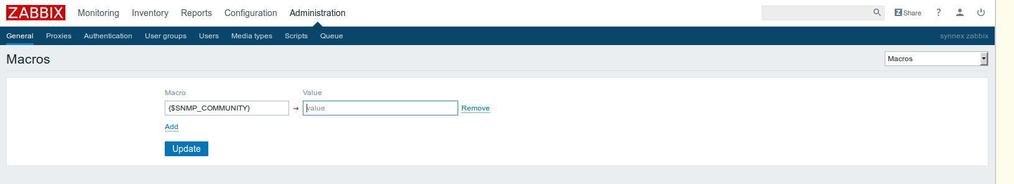

Configure template to monitor cpu usage.

Create new template
Configuration ---> Templates ---> Create Template.
Template name: Template SNMP CPU Usage;
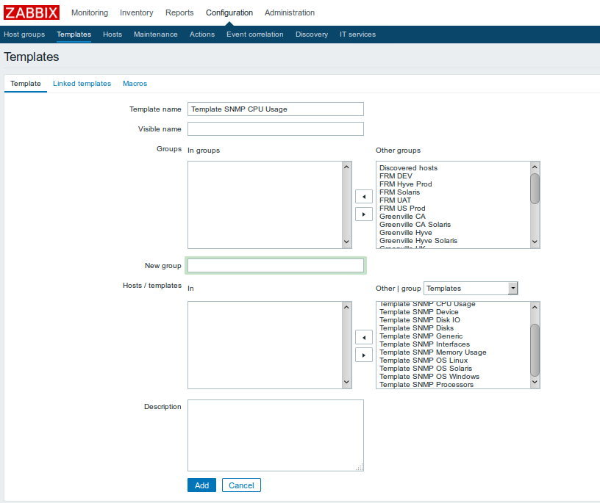

Create new application under this template, switch to Application tab.
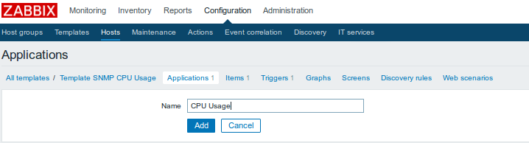

modify this template to add items at item tab.I. Installation of the software. 1
1. Install zabbix 2
2. Configure postgresql 2
1) Initialize the data store 2
2) Change the authentication method in /var/lib/pgsql/data/pg_hba.conf 2
3) Create user zabbix 2
3. Configure /etc/zabbix/zabbix-server.conf 3
4. Complete the installation via the http://ip/zabbix/ 3
II. configure templates 3
1. set up the macros SNMP_COMMUNITY; 4
2. Configure template to monitor cpu usage. 4
1) Create new template 4
2) Create new application under this template, switch to Application tab. 5
3) modify this template to add items at item tab. 5
4) Swith to trigger tab, create trigger for this item. 7
3. Configure disk/filesystem monitor templates 7
1) modify the regex expression for discovering the disks 7
2) modify Template SNMP Disks 8
4. Configure memory monitor template --- Template SNMP Memory Usage 11

Type:SNMPv2 agent
Key:CPUIdle
SNMP OID:UCD-SNMP-MIB::ssCpuIdle.0
SNMP community:{$SNMP_COMMUNITY}
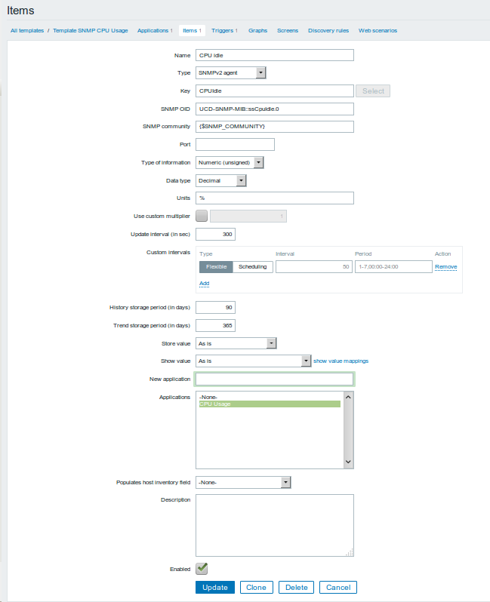

Swith to trigger tab, create trigger for this item.
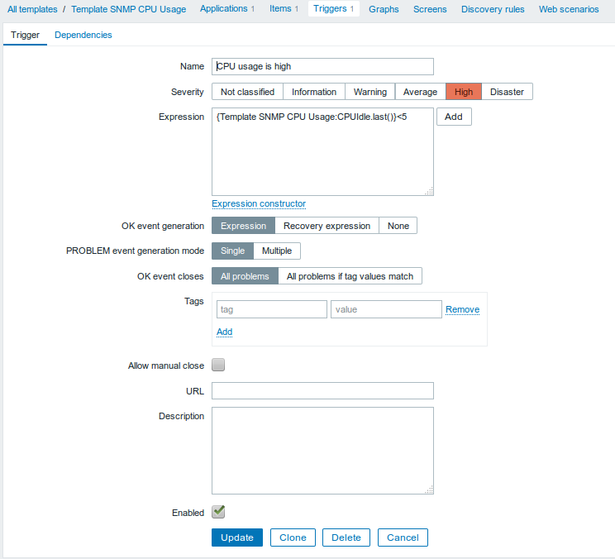

Configure disk/filesystem monitor templates

modify the regex expression for discovering the disks
Disk mount points and filesystem vary on different hosts , so we need to use regex expression to filter out the correct mount points.
Admin ---> General ---> Regular expressions--->Storage devices for SNMP discovery
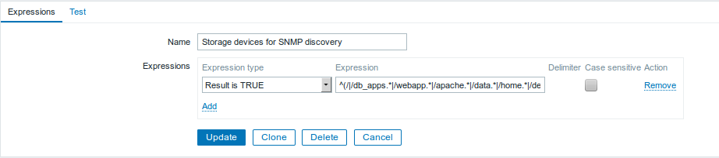
Expression: ^(/|/db_apps.*|/webapp.*|/apache.*|/data.*|/home.*|/dev_apps.*|/apps.*|/udata.*)$
We can also raise a test in the next “test” tab.

modify Template SNMP Disks
Since this template relay on auto-discovery, so we begin with “Discovery rules”.
The rule Disk partitions is used to discover all disks, and assign it to a macro {#SNMPVALUE} with values like / or /apps, it may have multiple values if the remote host has one more mount points. This macro is only available inside this template.
Item prototypes: is the monitor items based on preceding discovery. Zabbix offers 7 items officially, but we kept only 3. For the used and total disk, SNMP just return the block quantity, so I used this with converting them to readable K/M/G units, so I suffix blocks as its unit.

First item:
Name: Disk $1: Used
SNMP OID: HOST-RESOURCES-MIB::hrStorageUsed.{#SNMPINDEX}
SNMP community:{$SNMP_COMMUNITY}
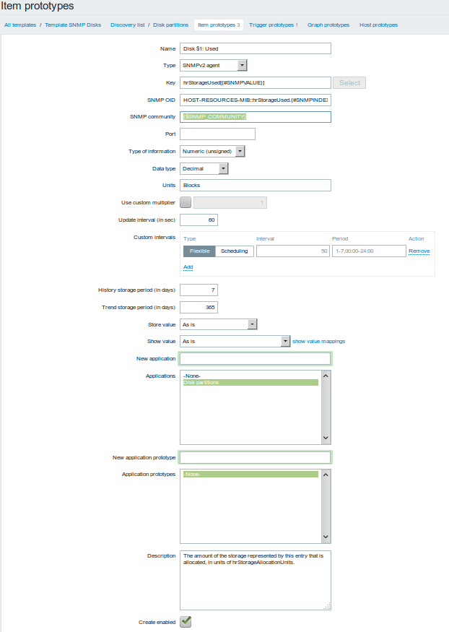

second item
Name:Disk $1: Total
SNMP OID: HOST-RESOURCES-MIB::hrStorageSize.{#SNMPINDEX}
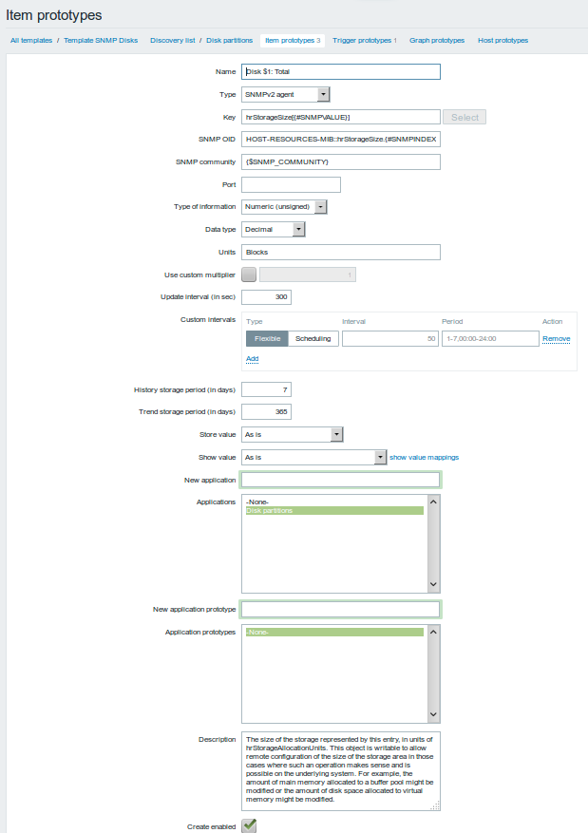

Third item is a calculated one based on preceding two items.
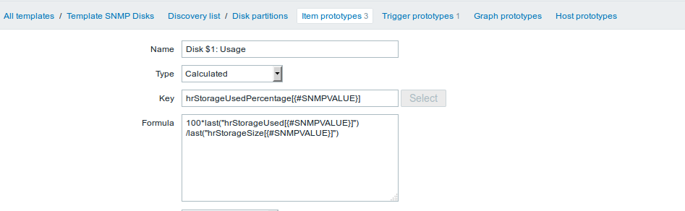

100*last("hrStorageUsed[{#SNMPVALUE}]") /last("hrStorageSize[{#SNMPVALUE}]")
Configure the disk usage trigger
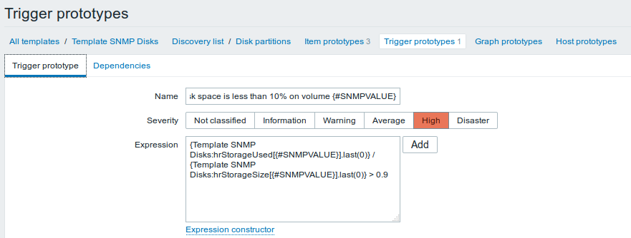

Configure memory monitor template --- Template SNMP Memory Usage
Repeat the same steps used to cpu/disks, we defined 3 items, “Memory: Avail” and Memory: Total are used the SNMP OID, and the last one “Memory: Usage” is also a calculated one with formula (1- last("MemAvail")/last("MemTotal") )* 100
Also we create a trigger for the memory usage.
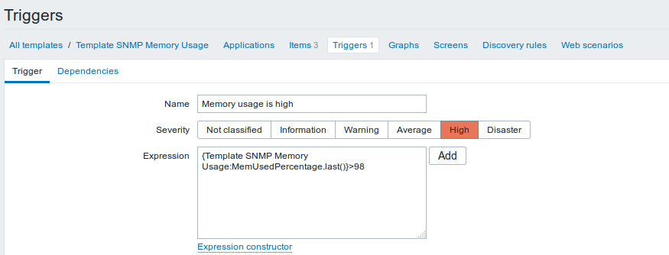

III. Configure the host discovery.
This will scan all the subnet to find the running hosts and add to appropriate host groups and link proper templates to it.

Create essential host groups.

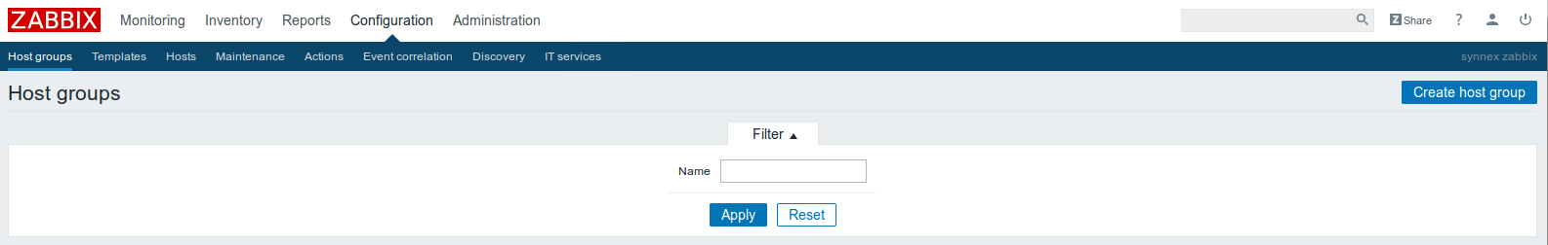

Create discovery rules.
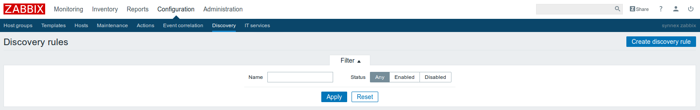
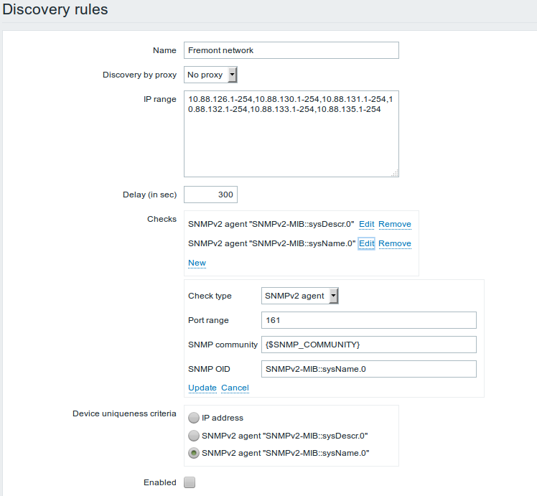

Create actions correspond to the discovery rules. The event source we choose “Discovery”.
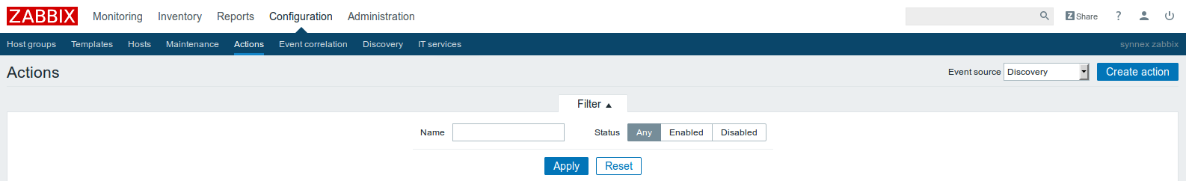
The actions window has two Tabs action and Operation.
The Action tab:
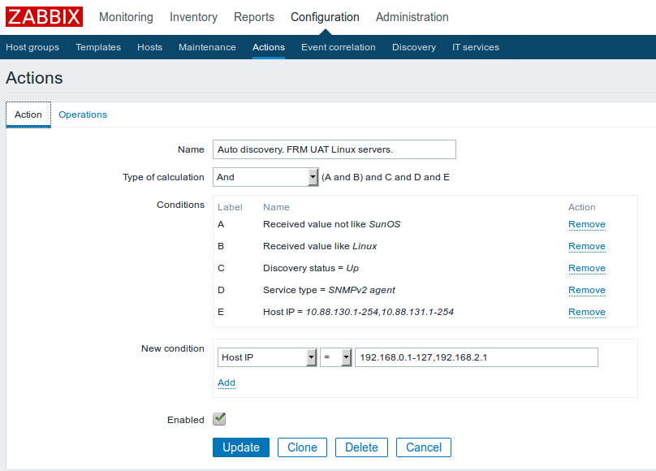
Operation Tab
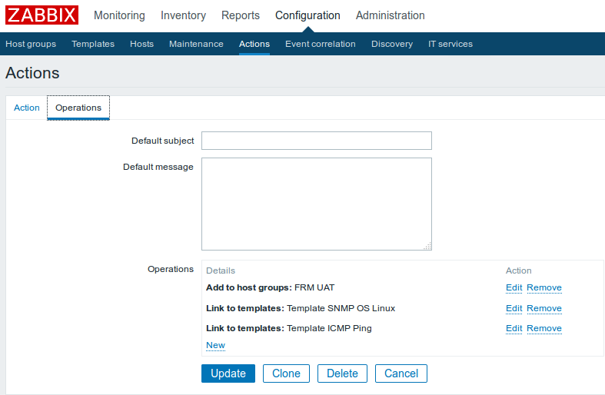

IV. Configure the email alerts.

Create/edit media in Administration ---＞Media Types --- Email.

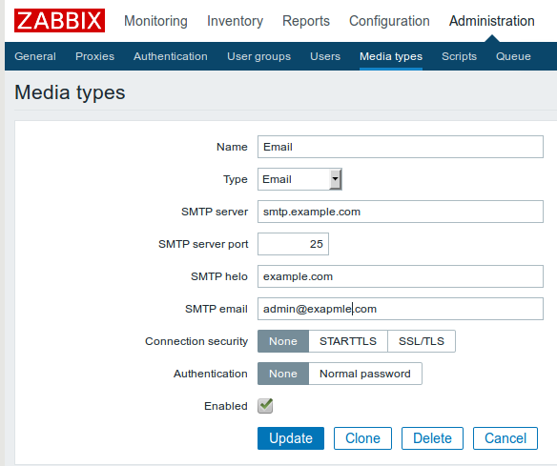

Add media to the user.
Administration ---＞ Users --->Admin. At the tab media, you can add a new media.

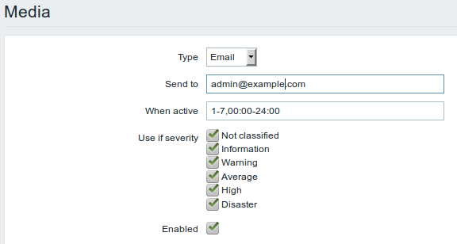

Configure the actions when there is a alert.
Configuration---＞ Actions,choose the Trigger as the Event Source. Click the “Report problems to Zabbix administrators” for editing.

